S4584569 ALEV AKTURK TUTORIAL 8

1. Display maximum wages for all positions.

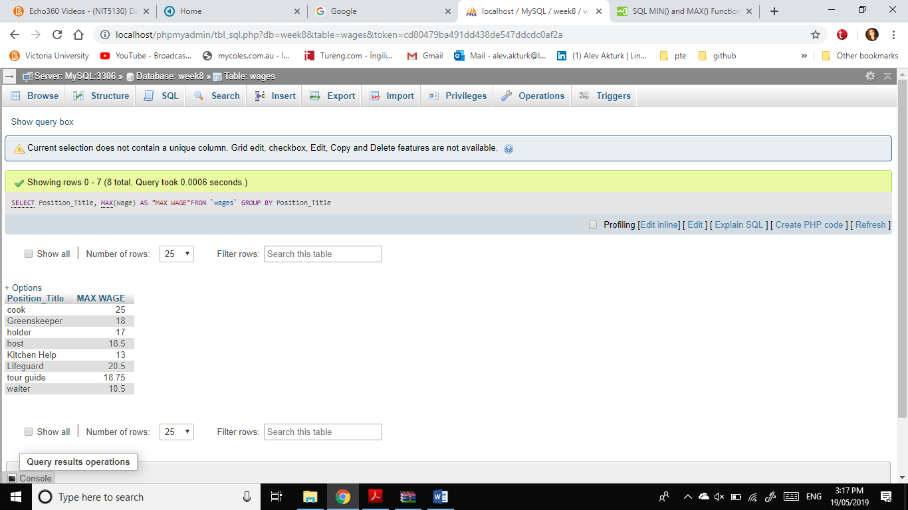[SELECT](http://localhost/phpmyadmin/url.php?url=https://dev.mysql.com/doc/refman/5.5/en/select.html) Position_Title, [MAX](http://localhost/phpmyadmin/url.php?url=https://dev.mysql.com/doc/refman/5.5/en/group-by-functions.html#function_max)(Wage) AS "MAX WAGE"FROM `wages` GROUP BY Position_Title

2) Display the position title and weekly salary for an employer, who earns more

than $18 per hour.

[SELECT](http://localhost/phpmyadmin/url.php?url=https://dev.mysql.com/doc/refman/5.5/en/select.html) Position_Title, Wage FROM `wages` WHERE Wage>18.00

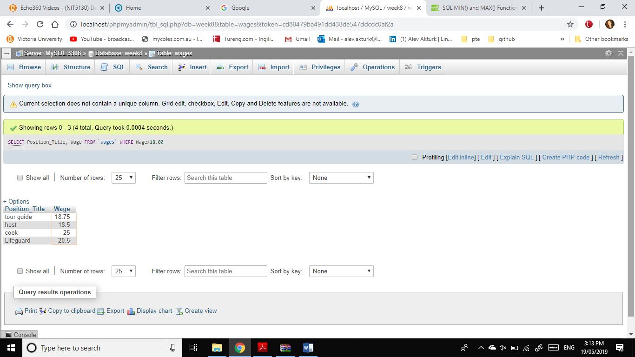

1. Display minimum wages for all positions.

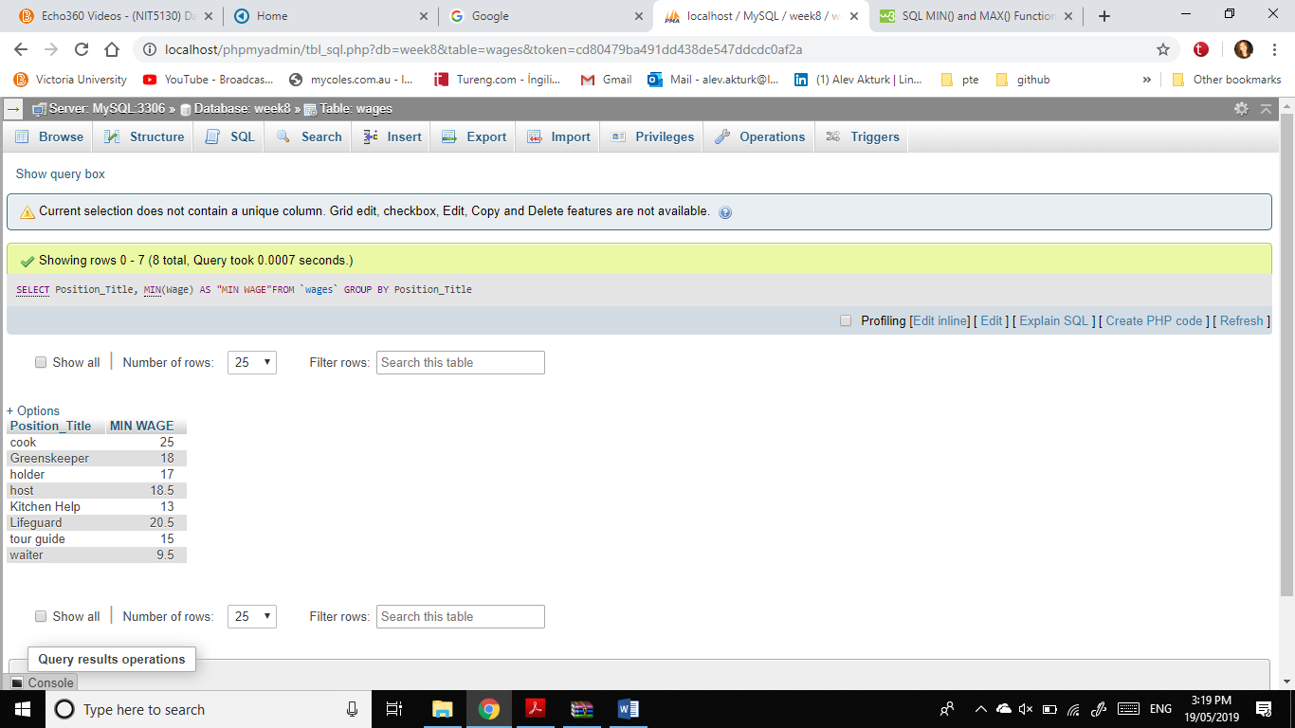[SELECT](http://localhost/phpmyadmin/url.php?url=https://dev.mysql.com/doc/refman/5.5/en/select.html) Position_Title, [MIN](http://localhost/phpmyadmin/url.php?url=https://dev.mysql.com/doc/refman/5.5/en/group-by-functions.html#function_min)(Wage) AS "MIN WAGE"FROM `wages` GROUP BY Position_Title

1. Display averages wages for all positions.

[SELECT](http://localhost/phpmyadmin/url.php?url=https://dev.mysql.com/doc/refman/5.5/en/select.html) Position_Title, [AVG](http://localhost/phpmyadmin/url.php?url=https://dev.mysql.com/doc/refman/5.5/en/group-by-functions.html#function_avg)(Wage) AS "AVG WAGE"FROM `wages` GROUP BY Position_Title

